

VELLORE INSTITUTE OF TECHNOLOGY – ANDHRA PRADESH (VIT-AP)
Amaravati, Andhra Pradesh – 522237
India

Engineering Clinics PROJECT REPORT

DEVELOPMENT OF FPGA BOARD USING ICE40UP5K

Submitted By:

1)Pranay Agastya Meghaji - 24BEV7014

2) Bollapragada Datta Naga Srinvas - 24BES7046

3) Gujjeti Avineesh - 24BCA7481

4) Manchuri Paawan Krishna Reddy - 24BEV7010

5) Sri Harsha M - 24BEV7091

6) Ritick Reddy - 24BEC7108

Under the guidance of prof : Sibi Chakkaravarthy S

Semester:WIN SEM 2025–26

INDEX

1. Abstract

2. Introduction

3. Background

4. Aim / Problem Definition

5. Methodology, Procedures, and Limitations

6. Challenges Faced

7. Results

8. Conclusion and Future Scope

9. References

1. Abstract

This project presents the design and development of a minimal standalone FPGA development board based on the Lattice Semiconductor iCE40UP5K FPGA using SPI flash boot architecture. The primary objective of the project is to create a simple, reliable, and beginner-friendly FPGA platform capable of autonomous power-on configuration and basic functional verification through LED blinking. Unlike microcontrollers, the iCE40UP5K FPGA requires external non-volatile memory for storing the configuration bitstream; therefore, SPI NOR flash memory was selected to provide persistent storage and automatic boot capability without requiring continuous support from an external microcontroller or programmer. The hardware design includes separate 3.3V and 1.2V power rails for FPGA I/O and core operation, proper decoupling capacitor placement, SPI flash interfacing, CRESET and DONE pin handling, and GPIO-based LED output for validation. A two-layer PCB was chosen to maintain simplicity and reduce fabrication cost while ensuring proper routing and grounding practices. The FPGA logic was implemented in Verilog using a counter-based LED blink design and synthesized using open-source tools including Yosys, nextpnr-ice40, and icepack. Successful LED blink verification confirms proper FPGA configuration, stable power delivery, and correct system operation. The project establishes a strong foundation for FPGA hardware design and serves as the first revision toward a more advanced development board with future support for debugging, communication interfaces, and embedded system applications.

2. Introduction

Field Programmable Gate Arrays (FPGAs) are semiconductor devices that can be configured by the user to implement custom digital logic. Unlike fixed-function integrated circuits, FPGAs allow repeated reprogramming, making them ideal for prototyping and embedded system development. This project focuses on designing a standalone FPGA development board using the iCE40UP5K device.

The goal is to build a simple yet complete hardware system that can independently support FPGA operation without relying on pre-built development kits. The project includes designing the power supply, configuration interface , and basic input/output components.

For this project, we chose the iCE40UP5K—a small but surprisingly capable FPGA chip. That meant figuring out everything ourselves—how to deliver clean power to the chip, how to load our designs into it, and how to connect basic inputs and outputs.

FULL PHYSICAL FPGA BOARD
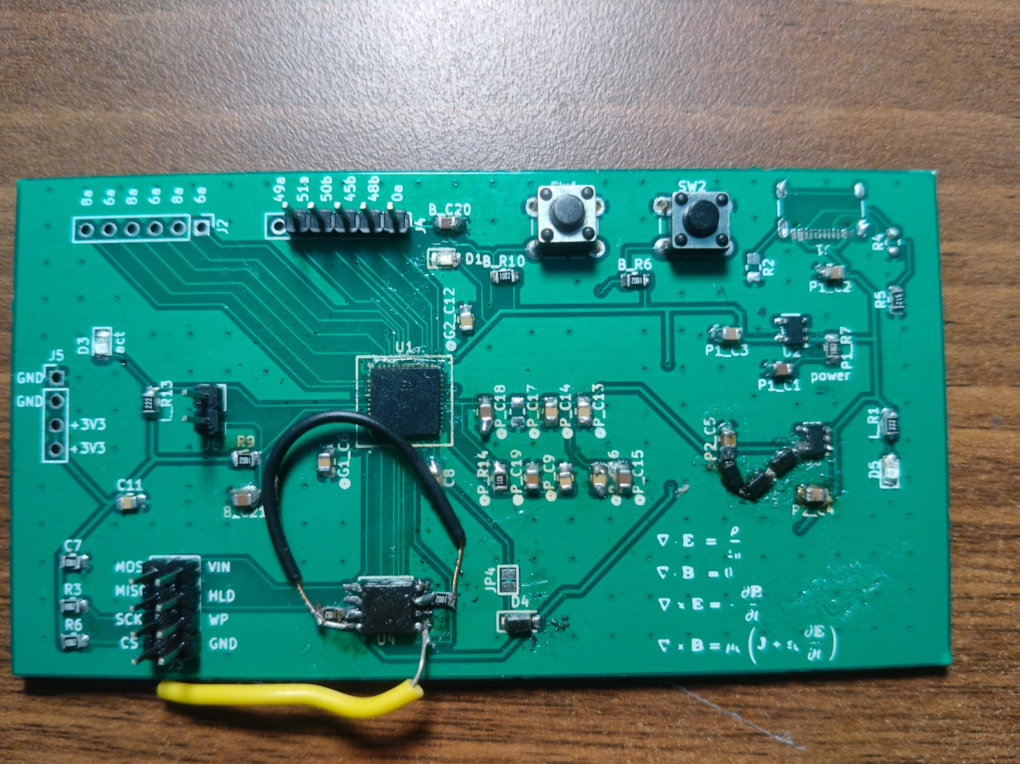

3. Background

Because they handle tasks at once, FPGAs now play a key role in building today's electronics. The iCE40UP5K fits neatly into small devices where saving power matters most.

Most of the time, engineers pick pre-built FPGA boards instead they build their own to really see how the parts fit together. Power control matters, along with smoothing out voltage swings, while setup often happens through serial links like SPI. Then again, stepping away from kits means facing layout challenges most skip on purpose.

Start with basics - voltage control matters most when FPGAs run tasks. Without clean paths for electricity, glitches pop up without warning. Think of it like water flow: blockages cause waves where there should be streams. This work ties back to how circuits handle charge shifts using parts that smooth spikes before they interfere. Logic patterns shape outcomes just as much as stable supply lines do behind the scenes.

A single FPGA chip gains new purpose when built step by step using clear rules. This setup shows what happens when raw hardware meets custom instructions. Through careful design, something empty starts running unique tasks. Each stage adds function until it works on its own.

4. Aim / Problem Definition

Commercial FPGA development boards often include numerous features that may not be necessary for basic learning or specific applications. These boards can be expensive, complex, and difficult to customize. As a result, there is a need to design a minimal, cost-effective FPGA board that includes only the essential components required for operation.

The main problem addressed in this project is how to design a standalone FPGA system from scratch while ensuring reliability and functionality. Challenges include providing stable power to the FPGA, ensuring proper configuration, and designing a compact PCB layout.

Additionally, ensuring correct interfacing between the FPGA and external components such as LEDs requires careful planning. Without proper design practices, issues such as noise, voltage drops, and configuration failures may occur.

Thus, the problem involves creating a simplified yet robust FPGA platform that demonstrates core functionality without unnecessary complexity.

5. Methodology, Procedures, and Limitations

Requirement Analysis
Develop a minimal standalone FPGA development board
- Use Lattice iCE40UP5K FPGA
- Support autonomous boot from SPI flash
- Provide stable 1.2V core and 3.3V I/O power rails
- Include external 12 MHz clock source
- Implement LED blink as initial functional validation
- Keep design beginner-friendly and low complexity

Choice of Components

1)FPGA :
ICE40UP5K is the beginer friendly board and highly documented and most affordable in the price range

2)PROGRAMMING INTERFACE:
we have 3 types of programming architectures

a)spi flash boot

Architecture
FPGA (SPI Master) ─── SPI Flash

b)external programmer(spi slave mode)
Architecture
External Device (PC / Pi / MCU) ─── SPI ─── FPGA

c)mcu assisted boot
Architecture
STM32 ─── SPI ─── Flash ─── FPGA

why we have preferred flash boot architecture over others
a)it is simple and decreases the hardware complexity when compared to others
b)most documented architectures
c)persistent memory
d)reduced boot time

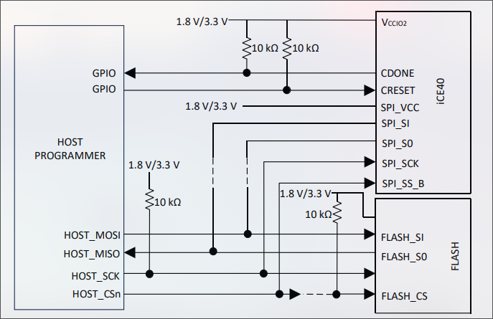

diagram for spi boot configuration

3)FLASH (W25Q128JVxxM)
highly documented components
easy to use

4)I/O COMPONENTS
a)LED which can be programmed to turn on
b)Button which can be programmed to detect in input
(which includes a debouncing circuit)dont include
c)I/O pins are provided for interfacing

5)POWER SUPPLY (TLV755XXPDBV)
a)TLV75533PDBV
b)TLV75533PDBV

we have used LDOs for a stable power
highly documented and beginner friendly and low complexity

Methodology

The methodology adopted for this project involved the design and implementation of a minimal standalone FPGA development board based on the Lattice Semiconductor iCE40UP5K FPGA with SPI flash boot architecture. The primary objective was to develop a simple and reliable board capable of autonomous power-on configuration and basic functional verification through LED blinking. The iCE40UP5K FPGA was selected due to its low power consumption, compact size, and strong support for open-source development tools. An SPI NOR flash memory was chosen as the configuration storage device to provide persistent non-volatile storage of the FPGA bitstream and enable automatic boot without requiring an external microcontroller or programmer during every startup. Separate 3.3V and 1.2V LDO regulators were used to generate the required I/O and core voltage rails for stable FPGA operation. The schematic design was developed by following Lattice reference guidelines, including proper power distribution, decoupling capacitor placement, SPI flash interfacing, CRESET and DONE pin handling, and GPIO connection for LED output. Since the design was intended to remain simple and cost-effective, a two-layer PCB was selected instead of a four-layer stack-up, with special attention given to short SPI routing, proper grounding, and close placement of decoupling capacitors to maintain signal integrity. The FPGA logic was written in Verilog using a counter-based LED blink design and synthesized using Yosys, while place-and-route was completed using nextpnr-ice40 and bitstream generation was performed using icepack. Finally, board bring-up and validation were carried out by measuring the 3.3V and 1.2V power rails, verifying SPI flash communication, monitoring the DONE pin for successful configuration, and confirming correct FPGA operation through stable LED blinking.

Procedure

The procedure followed for the development of the FPGA board began with defining the system requirements for a minimal standalone FPGA development platform capable of autonomous boot and LED blink verification. Based on these requirements, the Lattice Semiconductor iCE40UP5K FPGA was selected as the main processing device, along with an SPI NOR flash memory for bitstream storage, two LDO regulators for generating 3.3V and 1.2V supply rails, and an LED for output verification. The SPI flash boot architecture was selected to allow the FPGA to automatically load its configuration at power-up without requiring continuous support from an external microcontroller. The schematic was then designed by connecting all FPGA power pins to their respective voltage rails, adding decoupling capacitors near each supply pin, interfacing the SPI flash with the FPGA configuration pins, and implementing CRESET and DONE pin handling for configuration monitoring. An LED was connected to one of the FPGA GPIO pins through a current-limiting resistor for functional testing. After schematic completion, a two-layer PCB layout was created with careful attention to grounding, short trace routing for SPI signals, and proper placement of power and decoupling components to ensure reliable operation. The Verilog design for LED blinking was developed using a counter-based approach, synthesized using Yosys, and routed using nextpnr-ice40, followed by bitstream generation using icepack. The generated bitstream was programmed into the SPI flash memory using an external programmer. Finally, hardware bring-up was performed by verifying the power rails using a multimeter, checking FPGA configuration status through the DONE pin, and confirming successful operation by observing stable LED blinking after power-up.

`default_nettype none

module top (
output wire led
);
wire clk;

// Internal 48 MHz oscillator divided by 4 gives a 12 MHz fabric clock.
SB_HFOSC #(
.CLKHF_DIV("0b10")
) u_hfosc (
.CLKHFEN(1'b1),
.CLKHFPU(1'b1),
.CLKHF(clk)
);

localparam integer CLK_HZ = 12_000_000;
localparam integer HALF_PERIOD_TICKS = CLK_HZ / 2;

reg [22:0] counter = 23'd0;
reg led_on = 1'b0;

always @(posedge clk) begin
if (counter == HALF_PERIOD_TICKS - 1) begin
counter <= 23'd0;
led_on <= ~led_on;
end else begin
counter <= counter + 1'b1;
end
end

// Board LED D1 is wired directly from +3V3 to RGB0/pin 39.
// Use the UP5K constant-current RGB driver; there is no series resistor.
SB_RGBA_DRV #(
.CURRENT_MODE("0b1"),
.RGB0_CURRENT("0b000011"),
.RGB1_CURRENT("0b000000"),
.RGB2_CURRENT("0b000000")
) u_rgb_drv (
.CURREN(1'b1),
.RGBLEDEN(1'b1),
.RGB0PWM(led_on),
.RGB1PWM(1'b0),
.RGB2PWM(1'b0),
.RGB0(led),
.RGB1(),
.RGB2()
);

endmodule

`default_nettype wire

For all the other codes please refer this github link
codes

Limitations
The current FPGA development board design has several limitations due to its focus on simplicity and first-stage hardware validation. The board was intentionally designed as a minimal standalone platform for basic FPGA bring-up and LED blink verification, which limits its functionality for more advanced applications. Since the design does not include an external microcontroller such as an STM32, features such as in-system debugging, UART communication, USB-based programming, and runtime monitoring are not available in the current revision. The use of a two-layer PCB, while cost-effective and easier for initial fabrication, provides lower power integrity and signal quality compared to a four-layer design, especially for high-speed or more complex FPGA applications. Additionally, the absence of dedicated external memory such as SRAM or SDRAM restricts the board to small logic designs and prevents the implementation of memory-intensive applications. The board also excludes peripherals such as buttons, displays, communication interfaces, and high-speed I/O, which limits its use as a general-purpose development platform. Since the FPGA relies entirely on external SPI flash for configuration, any issue in flash programming or SPI routing directly affects successful boot operation. Furthermore, the project currently validates functionality only through LED blinking, which serves as a basic proof of operation but does not fully test timing performance, complex logic behavior, or real-world application reliability. These limitations are acceptable for the first revision and provide a stable foundation for future improvements in subsequent versions of the board.

7. challenges faced

1) LDO(TLV75512PDBV) had issues so the voltage is dropped using 3 silicone diode

2) SPI_WP(write protect) and SPI_HLD(hold) were not pulled up using an resistor so a pull up resitor is added manually to counter the issue

3)due to the above errors the flash was unable to go to the
write state/mode

4)making a debugger/programmer using stm32 bluepill

8. Results

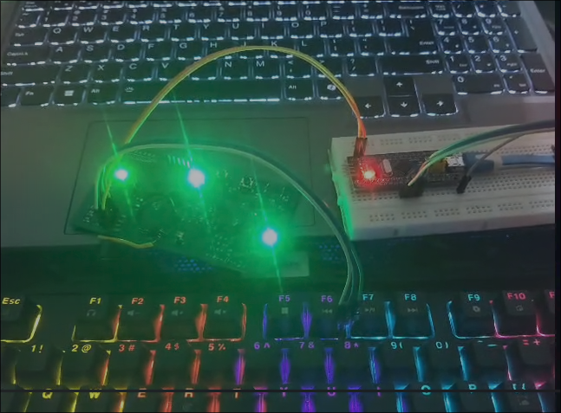
Here the middle ligth indicates the on cycle of the code

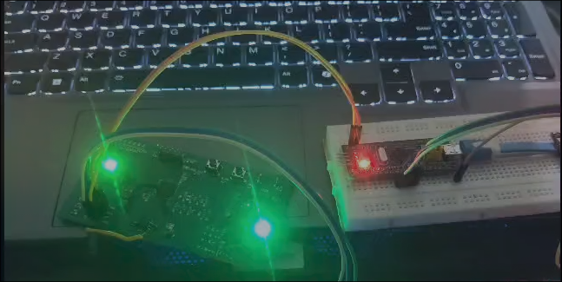

Here the middle ligth in the off condition indicates the off cycle of the code

9. Conclusion and Future Scope

Conclusion and Future Scope
This project successfully demonstrates the design methodology of a minimal standalone FPGA development board using the Lattice Semiconductor iCE40UP5K FPGA with SPI flash boot architecture. The board was developed with the objective of creating a simple, reliable, and beginner-friendly platform capable of autonomous configuration and basic functional verification through LED blinking. By selecting SPI flash boot architecture, the design achieved persistent bitstream storage, reduced hardware complexity, simplified debugging, and independent power-on operation without requiring an external microcontroller. Separate 3.3V and 1.2V power rails, proper FPGA configuration handling, and careful PCB layout considerations ensured stable operation of the system. The successful implementation of LED blink verification confirms that the FPGA configuration process, power delivery, and basic GPIO functionality operate as intended. This establishes a strong foundation for understanding FPGA board design and provides a reliable first revision for further hardware development.

The future scope of this project includes expanding the board from a minimal standalone platform into a more complete FPGA development system. In the next revision, an STM32 microcontroller can be integrated to provide in-system SPI flash programming, UART-based debugging, FPGA reset control, and status monitoring without affecting standalone FPGA boot. Additional peripherals such as push buttons, multiple LEDs, communication interfaces like UART, SPI, and I2C, and external memory modules such as SRAM or SDRAM can be added to support more complex digital designs. Upgrading the PCB from a two-layer to a four-layer design would further improve power integrity, signal quality, and routing reliability for advanced applications. Future work can also include implementing practical FPGA applications such as PWM control, sensor interfacing, communication protocols, and soft-core processor designs. These improvements would transform the current basic validation board into a full-featured FPGA development platform suitable for embedded systems research and advanced digital design experimentation.

10. References

FPGA chip iCE40UP5K SG48 datasheet, https://www.mouser.in/datasheet/3/248/1/FPGA_DS_02008_2_4_iCE40_UltraPlus_Family_Data_Sheet.pdf

https://0x04.net/~mwk/sbdocs/ice40/FPGA-TN-02006-2-3-iCE40-Hardware-Checklist.pdf

https://www.latticesemi.com/view_document?document_id=51987

https://github.com/icebreaker-fpga/icebreaker

